RWE is pushing ahead with controversial plans for the conversion of coal-fired power stations
From coal to biomass: from rain in the drop?
Energy company RWE wants to run its coal-fired power stations entirely on biomass by 2030. The CO2 released is stored underground or reused. Environmental organizations are strongly opposed. 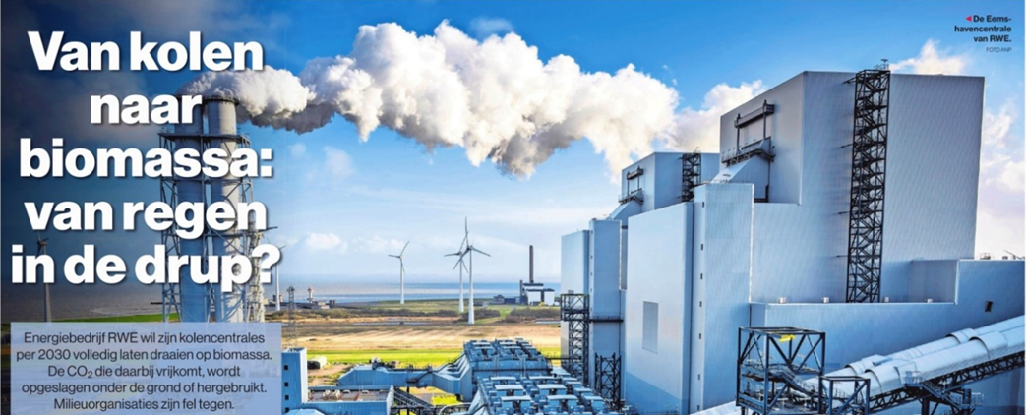
Edwin Timmer, Algemeen Dagblad, 10 November 2023
https://www.ad.nl/klimaat/plan-ombouw-kolencentrales-met-co2-afvang-ontlokt-nieuwe-strijd-om-biomassa-fnuikend-voor-de-bossen~af3f11e7/
The originally German energy company RWE believes it is taking a major step in the Dutch climate approach with its plan for a biomass power plant. With the Beccus (Bio-Energy Carbon Capture Utilization & Storage) project, carbon from burned biomass will soon be captured, stored and possibly reused in the coal-fired power stations in Geertruidenberg (Amercentrale) and the Eemshaven. RWE wants to store 11 to 14 megatons of CO2 annually in old gas fields under the seabed.
"That amount is equal to 7 to 9 percent of annual Dutch emissions," says RWE spokesperson Marjanne van Ginkel. Because biomass is climate neutral according to the (controversial) calculation rules of the UN climate panel IPCC, capture would even count as negative emissions for the Netherlands. Van Ginkel: "Experts agree that we will not achieve our climate goals without removing CO2 from the atmosphere."
RWE must stop using coal anyway. "Then you can close the power stations or see if there is an alternative." Closing both power stations in 2030 is not wise, the company believes. “Then there would be too big a gap in power generation. 4 million households use our electricity and heat. Biomass is a possible alternative.”
However, nature action groups do not like the plans. Earlier, the House of Representatives already had serious doubts about the technology that RWE wants to use. "RWE wants to burn 6 million tons of biomass in the Eemshaven. That is two hundred bulk carriers with 30,000 tons of wood pellets per year," says Fenna Swart, chairman of the Clean Air Committee (CSL). "It's detrimental to biodiversity and forests. This actually reinforces the climate problem." With 6 million tons, the Eemshaven power plant would even burn more than the planned Vattenfall biomass power plant in Diemen, whose environmental permit was recently annulled by the Council of State.
Very expensive
A coalition of international environmental organizations calls Beccus an 'extremely expensive, unproven technology'. CSL warns that taxpayers will soon have to cough up billions of euros again. Swart refers to the British environmental think tank Ember, which calculated in 2021 how much subsidy CO2 capture and storage would cost at the English Drax biomass power plant: 36.9 billion euros.
Searchinger
In June, researcher Timothy Searchinger from Princeton University spoke during a hearing in the House of Representatives. He disputes the idea that CO2 capture would make biomass climate neutral or even produce negative emissions. “When wood is harvested, at least half of the tree's carbon is lost and dissipates into the air. Carbon is also lost when drying wood and making pellets. According to Searchinger, a technique like Beccus prevents less than half of the total CO2 emissions from forest felling and wood burning. And the question is whether the forest will grow back.
RWE believes that the project is sustainable, although the company recognizes the sensitivity of the file. “No one claims that biomass is the only solution. But this is the path of transition," said Van Ginkel. There is another reason why the two power stations are indispensable according to RWE. "They help as adjustable power in addition to the fluctuating supply of sun and wind." Moreover, only 'residual wood' would be burned from production forests.
'Residual wood' is a myth, CSL responds. Entire trees disappear in wood pellet factories. Swart emphasizes that biomass is more polluting than gas and coal. “There is also sufficient gas as a transition fuel. Tennet indicated in 2022 that closing the coal-fired power stations will not endanger security of supply. As long as the government continues to pay billions of euros in subsidies, RWE will hide behind a smokescreen of stoked forests."
It is very important how the next cabinet positions itself. The Netherlands has become Europe's largest importer of wood pellets. Yet the cabinet chose a more critical course than Brussels. Under pressure from a European petition with 300,000 signatures, initiated by CSL, Minister Rob Jetten (Climate) decided to stop subsidizing new biomass projects in 2022. "I really want to prevent us from cutting down trees for electricity," Jetten said.
Timmermans
Brussels does give the green light for forest burning in its revised renewable energy directive. As European Commissioner, Frans Timmermans (Climate) refused to deprive biomass of the 'sustainable' label. Swart (CSL): "Remarkably enough, he is now campaigning for GroenLinks-PvdA with an election manifesto that actually wants to phase out biomass. It would have been better for our biodiversity, air quality and climate if he had thought of that earlier. Now we will be stuck with European legislation that encourages clear-cutting for another five to fifteen years."
The World Wildlife Fund recently published a report analyzing which EU policy measures undermine its own European climate goals. At the top: Brussels support for biomass combustion as an energy source.

